**Pneumonia X-ray Image Detection Using Deep Learning Algorithm**

**By:**

**Utsab Subedi**

**Sudeep Paudel**

**Date: 4/22/2024**

**Introduction:**

Pneumonia is an inflammatory condition primarily affecting the lungs' alveoli—the tiny air sacs responsible for gas exchange. This inflammation leads to the alveoli filling with fluid or pus, manifesting as symptoms such as a persistent cough (which may produce phlegm or pus), fever, chills, and difficulty breathing. The condition ranges in severity from mild to life-threatening. It is particularly dangerous for infants, the elderly, and those with weakened immune systems or chronic diseases like COPD, asthma, and heart failure. The infection responsible for causing Pneumonia can be bacterial, with Streptococcus pneumoniae being the most common culprit, viral or even fungal, with each type varying in severity and required treatment approach.

The risk factors for developing Pneumonia include chronic respiratory diseases, immune system impairments, smoking, and conditions such as diabetes that can weaken the body's natural defense mechanisms against infections. Diagnosis typically involves a combination of physical examination and diagnostic tests. A chest X-ray is the most straightforward and commonly used method to confirm Pneumonia, as it can clearly show the presence of fluid or pus in the lungs. Additional tests might include blood tests to assess the infection's severity and nature and sputum cultures to identify the specific type of microorganism causing Pneumonia, guiding targeted treatment strategies.

Figure 1: Comprehensive Illustration Normal versus Pneumonia Lung

**Pneumonia Detection**

Chest X-ray imaging is the most effective way to diagnose Pneumonia. Soft tissue produces a dark color, and hard tissues like bone produce a bright color. A pneumonia X-ray image often has an area of increased opacity, indicating the presence of fluid, which is the filling of air spaces in the lungs with fluid, pus, or cellular debris.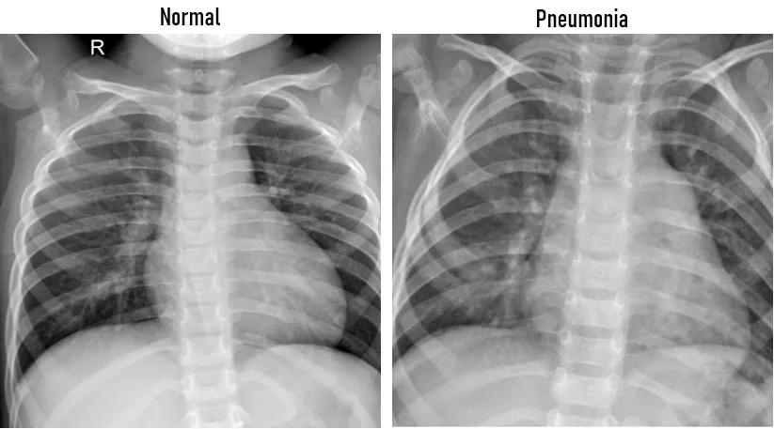

Figure 2: X-rays comparing lungs with or without Pneumonia.

**Purpose of developing these algorithms**   
The traditional approach to diagnosing Pneumonia through chest X-rays is fraught with challenges that can compromise its effectiveness and efficiency. Variability in diagnoses is not uncommon, as different radiologists may interpret the same images differently. Subtle and early manifestations of Pneumonia and atypical presentations are particularly prone to being overlooked. Moreover, radiologists often face high workloads, and the resulting fatigue can contribute to diagnostic errors. The situation is exacerbated by a global shortage of trained radiologists, which hits hardest in underserved areas with limited resources.

Consequently, this can lead to significant delays in reviewing X-rays and providing timely diagnoses. Over time, these conventional diagnostic methods are resource-intensive and economically burdensome, particularly when the scalability of expert radiologist services in remote or developing regions is constrained. These factors collectively underscore the pressing need for improved diagnostic solutions that are more consistent, rapid, and broadly accessible.

**Objective**

The core objective of our study is to enhance pneumonia diagnosis through a robust deep-learning model tailored to pediatric chest X-ray analysis. Our process begins with meticulous data preparation, ensuring the X-ray images are clean and structured for optimal model training. We then focus on constructing a deep learning model designed to pinpoint Pneumonia with high precision, thereby augmenting the diagnostic accuracy for healthcare professionals. Acknowledging the variability in image presentations, we train the model to recognize Pneumonia across diverse image qualities accurately. The model undergoes stringent validation and testing to confirm its reliability. Post-development, we aim to integrate the model seamlessly into clinical workflows to offer real-time support to medical staff. Finally, we plan to institute a continuous feedback mechanism for iterative model refinement, adapting to new data and real-world application feedback.

**Convolutional Neural Network (CNN)**

A Convolutional Neural Network (CNN) is a sophisticated deep learning algorithm, particularly in image recognition and analysis. Its deep architecture is a key feature, enabling it to extract and learn features from images autonomously and adaptively. This unique design, organized in layers, allows for specific transformations on input data. The layers typically include:

**Convolutional Layers:** These layers apply several filters to the input to create feature maps, capturing spatial hierarchies such as edges and patterns.

**Pooling Layers:** They reduce the spatial size of the feature maps, decreasing the number of parameters and computations in the network, thus controlling overfitting.

**Fully Connected Layers:**These layers perform high-level reasoning by taking the output from the previous layers and calculating the probability for each class or label in the task.

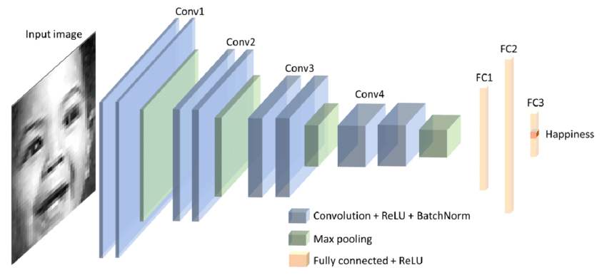CNNs are highly sought after for image classification tasks due to their ability to detect intricate patterns and image variations. This is particularly useful in recognizing complex conditions such as Pneumonia in chest X-rays. Their deep layered structure enables them to learn representations of features at various abstraction levels, enhancing their accuracy and the ability to generalize from one set of images to another. This practical application is precious in medical diagnostics. CNNs can significantly contribute to achieving high precision and recall rates, crucial for minimizing false negatives and false positives in disease detection.

Figure 3:Schematic Representation of a Convolutional Neural Network

**Other Models used:**

**AGG Net**

AGG Net, an advanced form of Gated Graph Neural Network, is proposed as a significant enhancement for feature extraction, specifically in medical imaging. Its utility lies in its ability to discern complex patterns often present in medical imagery, such as X-ray scans. AGG Net differentiates itself by incorporating sophisticated gating mechanisms and leveraging graph-based connections, enabling the network to better understand and learn from the spatial and structural relationships critical in X-ray image interpretation.

**Hybrid Model**

The integration of AGG Net with traditional Convolutional Neural Networks (CNNs) forms a hybrid model that brings together the best of both worlds: CNN's robustness in extracting hierarchical features and AGG Net's advanced pattern recognition capabilities. CNNs excel at identifying and learning from visual patterns and abnormalities, such as those indicative of Pneumonia, while AGG Net goes a step further to analyze the complex interrelationships between different regions within the images.

This hybrid approach ensures that the spatial hierarchies of features are not only captured through CNN's convolutional and pooling layers but also enhanced by AGG Net's ability to model the dependencies between disparate image regions. The result is a model that is exceptionally well-equipped for the precise and accurate classification of medical images, with a significant improvement in identifying conditions like Pneumonia.

**DenseNet**

DenseNet is structured to connect each layer to every subsequent layer in a feed-forward fashion. This unique connectivity pattern promotes the reuse of features, effectively enhancing feature extraction capabilities as each layer has direct access to the outputs of all preceding layers. This architectural choice facilitates the distinction between healthy and pneumonia-affected lung tissue and makes the network inherently more efficient—since it requires fewer parameters, reducing the computational burden. Additionally, DenseNet's design is beneficial for managing overfitting, a common challenge in medical imaging where datasets are often small and imbalanced. By reusing feature maps, the network operates more efficiently and scales better for handling large sets of X-ray images. Moreover, it ensures a smoother gradient flow, which is crucial for maintaining learning efficiency across the network, mainly when tasked with complex diagnostic objectives.

**VGG16**

On the other hand, VGG16 stands out with its deep architecture consisting of 16 layers. Its uniformity lies in using several convolutional layers of the same size followed by fully connected layers. This depth allows the network to perform a comprehensive analysis of X-ray images, extracting intricate features that are vital for identifying Pneumonia. The multiple layers in VGG16 progressively build a deep hierarchy of features—from basic visual elements to complex structures—essential for the nuanced task of pneumonia diagnosis.

DenseNet and VGG16 bring specialized strengths to the table. DenseNet has a feature-preserving and efficient design, and VGG16 has depth and thoroughness in feature extraction. Their integration into diagnostic workflows represents an advanced step towards automating and refining the detection of Pneumonia from X-ray imagery.

**Dataset:**

The dataset utilized for this medical imaging project comprises pediatric chest X-ray images sourced from the Guangzhou Women and Children's Medical Center. It consists of two distinct categories: images depicting Pneumonia and those classified as usual. The dataset is organized into three separate folders for training, validation, and testing and includes 5,863 JPEG images. These images represent the anterior-posterior view of the chest X-rays of patients aged between 1 and 5 years old.

We performed rigorous selection, and a quality control process was implemented to ensure the high quality of the data, which included an initial screening to filter out low-quality or unreadable scans, thus maintaining a dataset standard suitable for practical AI training. The diagnostic process involved initial evaluations by two expert physicians and an additional review from a third specialist to confirm diagnoses and mitigate any grading discrepancies. Such meticulous curation of the dataset is crucial for the development of a reliable AI system capable of accurately diagnosing pediatric Pneumonia from chest X-rays.

**Methods and Libraries**

**torch:** This library offers a wide range of tools and libraries for deep learning and serves as the foundation for using PyTorch.

**torch.nn:** Provides modules and classes to help create neural networks in PyTorch.

**numpy:** A fundamental package for scientific computing, it offers support for multidimensional arrays and matrices, along with a collection of mathematical functions to operate on them.

**pandas:** Useful for data manipulation and analysis, particularly for handling tabular data.

**torchvision:** Assists with loading and transforming images, which can be particularly helpful when dealing with datasets of images. It also provides access to pre-trained models.

**matplotlib.pyplot:** A plotting library used for creating static, interactive, and animated visualizations in Python.

**time, copy, os**: Standard Python libraries for timing operations, copying objects, and interacting with the operating system.

**tensorflow & keras:** TensorFlow is an end-to-end open-source platform for machine learning, and Keras is a high-level neural networks API running on top of TensorFlow.

**PIL (Python Imaging Library):** Used for opening, manipulating, and saving many different images file formats.

**Model Evaluation**: The code uses a method to evaluate the deep learning models after training, likely involving the evaluate function to determine accuracy.

**ImageDataGenerator:** Utilized for augmenting the data by applying transformations to increase the diversity of the dataset.

**Layers:** Within Keras, layers are stacked to build neural networks which involves convolutional layers, activation layers, pooling layers, and fully connected layers, as indicated by the layers module from tensorflow.keras.

**Results**  
**Classified Xray Images**

**Average of Normal and Pneumonia Xray Images**

**

The first image, labeled as "Standard Deviation PNEUMONIA," displays the variability in pixel intensity across a collection of pneumonia X-ray images. The grayscale tones indicate the level of deviation from the mean pixel intensity: the brighter the area, the higher the variability. This variation can reflect the diverse presentations of Pneumonia in the lungs, highlighting regions with significant differences in texture and density due to the infection.

The second image, "Standard Deviation NORMAL," mirrors the first but for a dataset of typical, healthy X-ray images. It maps out the inherent variability in pixel intensity found in unafflicted lungs. This is a benchmark for typical variation in lung imagery without infection or inflammation.

Lastly, the "Difference Between Normal & Pneumonia Average" is a heat map that visually contrasts the average differences between the two datasets. The color-coded representation—red indicating higher deviation in the pneumonia dataset and blue indicating lower or equivalent deviation in the normal set—pinpoints the divergent features that could potentially be used for automated pneumonia detection. Such heat maps are instrumental in identifying the salient features that can train machine learning models to discriminate between healthy and pneumonic conditions with greater accuracy.

**Comparison between the models used in test accuracy after running the model.**

The bar chart presents test accuracy results for four different deep-learning models. From the data:

**DenseNet** demonstrates the highest accuracy at 89.55%, indicating its architecture is well-suited for the task, possibly due to efficient feature reuse and robust gradient flow.

**CNN**, with an accuracy of 81.89%, also performs well, suggesting a good balance of depth and complexity for capturing relevant features in the X-ray images.

**Hybrid CNN** shows a lower accuracy of 74.20%. This may suggest that integrating multiple architectures didn't translate into better performance for this task or requires further tuning.

**VGG16** has the lowest accuracy at 37.50%, which might indicate that this model, despite its depth, is not as effective at generalizing or capturing the necessary features from the pediatric X-ray dataset. It might also suffer from overfitting due to its high number of parameters.

The chart implies that while DenseNet and standard CNNs are more effective for this application, hybrid approaches and deeper networks like VGG16 may not yield improved results and might require more data or refinement to reach their potential.

**Model Testing using the CNN model.**

The image showcases two chest X-rays evaluated by a deep learning model for pneumonia detection. On the left, the model assigns a low probability (7.52%), correctly identifying a normal X-ray, whereas the right X-ray has a high probability (99.79%), correctly indicating the presence of pneumonia. These outputs demonstrate the model's ability to discern between healthy and diseased lung conditions.

**Conclusion:**

The study set out to harness the capabilities of deep learning algorithms for detecting Pneumonia from pediatric chest X-ray images. DenseNet emerged as the superior model, achieving the highest test accuracy, likely due to its architectural efficiency and effective feature reuse. The standard CNN model also performed commendably, balancing depth and complexity adeptly to extract relevant features. The Hybrid CNN, while innovative, displayed lower accuracy, indicating that the amalgamation of multiple architectures may not necessarily confer an advantage in this context and could require additional optimization. VGG16, though a deep and established model, fell short in accuracy, potentially due to overfitting or a mismatch between the model's complexity and the dataset's characteristics.  
**Limitations:**

The study encountered several inherent limitations in applying deep learning to medical diagnostics. Firstly, the performance of the models might be affected by the size and diversity of the dataset. While the models performed well on the available images, they may need to be validated on a broader range of data to ensure their generalizability. Overfitting presents another challenge, particularly for complex models like VGG16, which might necessitate further regularization or data augmentation methods to generalize better. Integrating these models into clinical workflows also remains a significant hurdle, as it requires technical deployment and acceptance by medical professionals, adherence to regulatory standards, and continuous performance monitoring. Lastly, the computational demands of training and running such deep learning models can be substantial, potentially limiting their use in resource-constrained environments.

**References**

* Varshni, D., Thakral, K., Agarwal, L., Nijhawan, R., & Mittal, A. (2019, February). Pneumonia detection using CNN based feature extraction. In *2019 IEEE international conference on electrical, computer and communication technologies (ICECCT)* (pp. 1-7). IEEE.
* GM, H., Gourisaria, M. K., Rautaray, S. S., & Pandey, M. A. N. J. U. S. H. A. (2021). Pneumonia detection using CNN through chest X-ray. *Journal of Engineering Science and Technology (JESTEC)*, *16*(1), 861-876.
* Shorfuzzaman, M., & Masud, M. (2020). On the Detection of COVID-19 from Chest X-Ray Images Using CNN-Based Transfer Learning. *Computers, Materials & Continua*, *64*(3).
* Mahmud, T., Rahman, M. A., & Fattah, S. A. (2020). CovXNet: A multi-dilation convolutional neural network for automatic COVID-19 and other pneumonia detection from chest X-ray images with transferable multi-receptive feature optimization. *Computers in biology and medicine*, *122*, 103869.